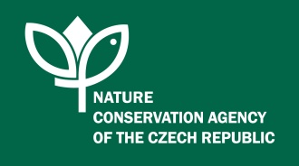

Proceedings
Conference on Large Carnivores‘ Protection in the Carpathians

Rožnov pod Radhoštěm
Czech Republic
October 18-21, 2016

This project of the Conference is funded by the German Federal Environment Ministry’s Advisory Assistance Programme (AAP) for environmental protection in the countries of Central and Eastern Europe, the Caucasus and Central Asia and other countries neighbouring the European Union. It is supervised by the Federal Agency for Nature Conservation (BfN) and the German Environment Agency (UBA).
The responsibility for the content of this document lies with the authors.
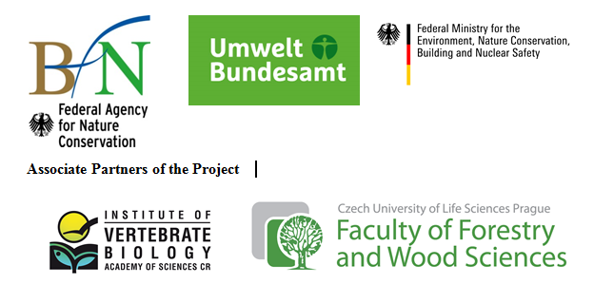
Content

1. Foreword 3
1. Conference Objectives: 3
2. Results of the Conference: 4
2. National situations 5
1. Status of large carnivores in the Czech Republic 5
2. Status of large carnivores in Hungary 6
3. Status of large carnivores in Poland 7
4. Status of large carnivores in Romania 8
5. Status of large carnivores in Serbia 9
6. Status of large carnivores in Slovakia 10
7. Status of large carnivores in Ukraine 11
3. Summary of the national situations 13
4. Objectives of Carpathian cooperation towards population level management 15
5. Results of discussions on national levels – country teams 16
6. Memorandum of Cooperation between the Secretariat of the Framework Convention on the Protection and Sustainable Development of the Carpathians and the International Council for Game and Wildlife Conservation (CIC) 17
7. Annex I – Declaration of the participants 18
8. Annex II – Memorandum of Cooperation 20
9. Annex III – pictures from the Conference 23

- Foreword
The Carpathian region harbours one of the most important large carnivore populations (the Eurasian lynx, the Brown bear, and the Grey wolf) in Europe. The above mentioned mammalian species require extensive, non-fragmented habitats to establish their large home ranges and to allow long-distance movements. Despite their long-term protection in some countries within the region, and their functional role as ecosystem keystone species, these top predators have been considered to be conflict species there.
Thus, the Framework Convention on the Protection and Sustainable Development of the Carpathians (The Carpathian Convention), namely its Protocol on Conservation and Sustainable Use of Biological and Landscape Diversity, together with the Carpathian Convention Working Group on Conservation and Sustainable Use of Biological and Landscape Diversity (The Biodiversity Working Group) pay special attention to effective large carnivores` conservation.
One of the main priorities of the Czech Presidency to the Carpathian Convention (2014-2017) has been to reduce landscape fragmentation, particularly caused by uncontrolled development of settlements and transport and other linear infrastructure. The issue is also closely related to the EU´s Green Infrastructure, dealing with landscape permeability and connectivity, and it uses, inter alia, the BioREGIO Carpathians Project outputs (Common Integrated Management Measures for Large Mammals) and experience of the sister Alps Convention.
The Conference was organised to enhance the necessary co-operation within Carpathian countries in large carnivores’ conservation and to support the debates on the reasonable coexistence of large carnivores with humans. Experts from governmental bodies, universities, academia and NGOs from Carpathian countries (the Czech Republic, Hungary, Poland, Romania, Serbia, Slovakia, and Ukraine) were present as well as experts from other countries. The Conference offered a suitable platform to share knowledge and to exchange experience and it was a kick-off for further common dialogue on large carnivores’ successful survival within the Carpathian region. The 8th Meeting of the Carpathian Convention Working Group on Conservation and Sustainable Use of Biological and Landscape Diversity (WG Biodiversity) took place back to back to the Conference on October 20th. 2016.

  - Conference Objectives:
- To share and to exchange information on large carnivores` monitoring and conservation within the Carpathian region;
- To establish an informal expert panel for large carnivores within the Carpathian Convention which will focus on developing and implementing future common large carnivores’ management plan in the Carpathians;
- To establish a formal partnership between the Carpathian Convention and the International Council for Game and Wildlife Conservation (CIC).

  - Results of the Conference:
- The representatives of Parties to the Carpathian Convention gained knowledge on large carnivores’ protection in other Carpathian countries;
- The representatives from EU accession countries (Ukraine, Serbia) gained knowledge on the EU legislation on large carnivores conservation;
- Transnational network was be established for further common Carpathian dialogue on large carnivores’ conservation;
- The Memorandum of Cooperation between the Secretariat of the Carpathian Convention and the International Council for Game and Wildlife Conservation was signed;
- The Common Declaration of the Conference participants and the members of the Carpathian Convention Working Group on Conservation and Sustainable Use of Biological and Landscape Diversity (WG Biodiversity) on the Management and Protection of Large Carnivores in the Carpathians was adopted.

- National situations

  - Status of large carnivores in the Czech Republic
Barančeková Miroslava¹, Červený Jaroslav², Koubek Petr¹, Krojerová Jarmila¹
¹Institute of Vertebrate Biology of Academy of Sciences, Czech Republic
²Faculty of Forestry and Wood Sciences, Czech University of Life Sciences, Prague

In the Czech Republic, large carnivores are specially protected species (Act No. 114/1992 Coll., as amended later). While the Brown bear (Ursus arctos) and the Grey wolf (Canis lupus) are listed among the critically endangered species, the Eurasian lynx (Lynx lynx) is classified as an endangered species. All three species are listed in the above categories also in the Red List of Threatened Species in the Czech Republic (Vertebrates) and are listed also in the Hunting Law as a game with a year round protection (Act No. 449/2001, as amended later). As their population numbers cannot be controlled legally, all damages caused by large carnivores on the human health, domestic animals (defined species of domestic animals including guarding dogs) and bee colonies are compensated by the Government (Act No. 115/2000 Coll., as amended later).
The Beskydy/Moravian-Silesian Beskids Mts. Protected Landscape Area (PLA) and Site of Community Importance is the only site in the Czech Republic where all three species of large carnivores can be found. Their existence depends on the status of all three species in Slovakia there. At present the only species with permanent occurrence in Beskydy PLA is lynx (approximately 7-10 individuals), while wolves and bears occur only occasionally (migrants). The population numbers given before 2010 were rather different – 15 - 25 lynxes, 5 - 17 wolves, and 2 - 5 bears. The numbers were based solely on the field monitoring, while those after 2010 are supported by the combination of genetic analyses, camera-trapping and field monitoring. However, the decrease in population numbers does not result only from the changed approach. Also largely negative attitude of the target groups (hunters and livestock breeders) to large carnivores has been persisting, despite the long term efforts to change it. Illegal hunting (poaching), car collisions and changes in large carnivore management in neighbouring countries have been certainly contributing to the overall decrease.
The most abundant lynx population in the Czech Republic occurs in its south-western part, in the Šunava Mts. National Park and Protected Landscape Area. It had been established by reintroduction in the 1980s and it increased both in numbers and distribution range during the 1990s up to 100 – 120 individuals. Since 2000 the population has been decreasing and at present it is expected to consist of approx. 60 – 70 individuals. The reasons believed to be behind the decline are the same as in the Beskydy PLA. However, just like in the Beskydy PLA, the population numbers from the period before 2000 were based solely on the field monitoring. Thus it is possible, that the real numbers in the 1990s were in fact lower and the following decrease is not so sharp.
At present, the Grey wolf is the only large carnivore whose population in the Czech Republic increases. The first information about the presence of wolves in northern Bohemia (the Kokořínsko PLA) appeared in 2013. The first cubs were born there in 2014, followed by two more in 2015, 2016 respectively, which bring the number of wolves in the Kokořínsko PLA up to 10 individuals. Genetic analyses confirmed that the population is related to the Central-European lowland population inhabiting Germany and north-western Poland. The origin of wolves living in the Broumovsko PLA (eastern Bohemia) and in the Šluknov region (the northern Bohemia) has not been confirmed yet, even though it can be expected that they also are of the same origin as the wolves in the Kokořínsko PLA.

  - Status of large carnivores in Hungary
László Szemethy¹ , Péter Gombkötő ²
¹ St. István University, Institute for Wildlife Conservation
² Bükk National Park Directorate

The Grey Wolf, the Eurasian lynx and the Brown bear had disappeared in the 19-20 centuries from Hungary. Due to spontaneous recolonization from the Slovakian parts of the Carpathians increasing number of individuals were observed in northern Hungary. All the three species are strictly protected in the country.
Permanent occurrence and breeding of wolves were found in the Bükk Mountains and the Aggtelek region and several sporadic occurrences were also observed on other areas. The numbers have increased in the last decade, now it could be maximally 25-30 individuals. Lynxes show sporadic occurrences in Northern Mountains, where 5-10 individuals occur. The population trend is doubtful. Bears were observed more frequently during the last decade than earlier, but at low numbers, 1-5 individuals. As the population densities are very low human-large carnivore conflicts are rare.
Hungary is in special situation with respect to large carnivore conservation. We are on the edge of the distribution range where spontaneous recolonization has been progressing since the 1980s, but it still has not resulted in establishing stable and viable populations. Consequently, the main goal of LC conservation in Hungary is to stabilize the occurrence and to support establishing breeding populations. The causes of the failure have not been known yet. The most popular explanation is the illegal killing, but very few cases were proved. The habitats are considered to be good and similar to Slovakian ones, but detailed habitat suitability analyses are still lacking. The management influence and status of source populations as well as the permeability of corridors have also not been known. To promote the recolonization more intensive transboundary cooperation, synchronisation in different management activities and more focused conservation plans on appropriate space and time scaling are necessary.
The legal and administrative background of LC conservation has been there since 1996, when the act on nature conservation was codified. Life Nature project gave LC conservation a stimulus in 2001-2006. Conservation plans for wolf and lynx were adopted in 2004 (but not for bear), and multilevel countrywide monitoring system was elaborated. The conservation plans shall be updated in the next years. The monitoring has not been fully implemented across the whole country nowadays, but NPs along the Slovakian border carry out different ways of monitoring. Methodology has recently been improved with analysis of genetic markers and camera traps. Countrywide monitoring for LCs, unified up-to-date methods and more equipment are needed.

  - Status of large carnivores in Poland
Sabina Nowak¹, Nuria Selva², Robert W. Mysłajek³
¹Association for Nature „Wolf”
²Institute of Nature Conservation Polish Academy of Sciences
³Institute of Genetics and Biotechnology, Faculty of Biology, University of Warsaw

Large carnivores (hereinafter LC) have been strictly protected in whole Poland – the Brown bear since 1952, the Eurasian lynx since 1995, and the Grey wolf since 1998. They are listed among species requiring conservation measures; e.g. a seasonal protection zone from the 1st April to 31st August, with a radius of 500m, may be established around breeding places of the wolf and lynx. Similar zones may be established around winter lair of the brown bear, between the 1st November and 30th April. The protection of breeding sites is ineffective as the sites are discovered a posteriori and almost no sites have been subject to specific legal protection.
Poland ratified the Bern Convention in 1995, but the wolf was excluded from Appendix II. Similarly, according to a derogation obtained by Poland, the wolf has been left in Annex II to the EU Habitats Directive, but also has been moved from Annex IV to Annex V. Implementation of the Habitat Directives allowed establishing f Natura 2000 sites, which protect LC habitats. Poland has also adopted Council Regulation (European Commission) No. 338/97 which stipulates special procedures for the regulation in the trade of LC trophies and body parts within Poland and from abroad. All permits for the import or export of LC trophies must be approved by the National Council of Nature Conservation – an advisory body to the Polish Ministry of the Environment.
There is no nation‐wide system for LC monitoring in Poland. Official information on the population size is published by the Central Statistical Office. However, these estimates are made on the basis of annual reports provided by the Regional Directorates of Environmental Protection, which are themselves based on information obtained from local NGOs, scientists, environmentalists, forest divisions and hunters. In some areas, the population numbers are based on data collected in well‐conducted censuses, monitoring schemes or scientific projects, while in others the numbers are based on guestimates or simply by the summing up of numbers estimated by forest divisions or hunting clubs, usually without following any methodology. In contrast to the lack of national monitoring schemes organized by governmental bodies, research projects on LC in various parts of Poland have been conducted very intensively resulting in numerous peer-reviewed papers published. Consequently, knowledge about the biology, ecology and genetics of the LC species in Poland is quite good.
According to official data provided by the Polish Central Statistical Office, in 2014 there were 1,276 wolves, 309 lynxes, and 163 brown bears, recorded across the whole country. The statistics do not provide any measure of the accuracy in the number estimates (as they are not done scientifically) and do not consider the transboundary character in many LC populations in Poland. There is also not any officially established system or procedures for interventions in emergency situations. Poland has not implemented yet management plans for any of the three LC species.

  - Status of large carnivores in Romania
Silviu Chiriac1, Ioan Mihai Pop2, Cristian-Remus Papp3

1 Environmental Protection Agency, WOLFLIFE project
2 Association for the Biological Diversity Conservation
3 WWF DCP, Romania

The presentation gives an overview of the Romania's large carnivores' populations and the main conservation and management challenges and obstacles related to them.
Romania harbours most of the large carnivores in terms of numbers not only in the Carpathians but also in Europe. However, there are several management issues emerging from the fact and several debates between conservationists and hunters especially. One major discussion for instance deals with the estimation of the large carnivore numbers, which is primarily developed by hunters. The accuracy of this estimation and the methodology it is based on is questioned by most nature conservation organisations and actors, considering that any management decision and measure in the end should be based on sound and reliable data collected in the field.
Although the large carnivore species are strictly protected in Romania, hunting them has been allowed until October 2016 (when the Romanian Ministry of the Environment took the decision to ban hunting and to reform the whole large carnivore management system) based on derogation system to conservation measures aiming at reducing the damages caused by these animals and the conflicts with them. The approach has not been (fully) justified considering that the number of conflicts with large carnivores has not decreasing.
Main threats the large carnivores face in Romania and their effect on the populations were highlighted. The mitigation of these threats is not an easy task and should involve inter institutional communication and cooperation.
Other items covered by the presentation included: types of conflicts with large carnivores, compensation scheme for damages, its implementation and consequences on the whole management system, perception of carnivores by humans, conservation challenges and achievements.

  - Status of large carnivores in Serbia
Duško Ćirović¹ and Milan Paunović²
¹Faculty of Biology, University of Belgrade
²Natural History Museum

The Grey wolf, the Eurasian lynx and the Brown bear are the three large carnivore (LC) species in Serbia. Each species has a different legal status and population trends. The lynx and bear are strictly protected species. The grey wolf in majority part of its distribution range (southern from Sava and Danube rivers) is game species, protected with the close season (which is open whole year!), but in fact without any protection. In the north Province of Vojvodina (north from Danube and Sava rivers) it is strictly protected species, protected by the close season whole year.
Grey wolves from Serbia belong to two European populations: the Carpathian and Dinaric-Balkan ones. General population trend is stable/slight increase. The Eurasian lynx also belongs to two populations: the Carpathian and Balkan populations. The Carpathian population has slightly been increasing, while the Balkan population has been decreasing. Serbia is the only European country with three Pan-European Brown bear populations. Bears from Serbia belong to the Dinaric-Pindos, Carpathian and Eastern Balkan populations. Such presence of different LC trans-boundary populations within Serbia, situated at the edges of the country, make difficulties for their monitoring, management and conservation.
In 2007 National Strategic Plans necessary for conservation of all three LC species in Serbia have been developed. The distribution, abundance, population trend, habitat requirements, threat factors/drivers, proposed monitoring activities and management requirements for each species are elaborated and documented. The documents were supposed to be background for National Action and Management Plans for all three species. Unfortunately, Strategic Plans have never been officially accepted and implemented and now they have been outdated. Meantime, a couple of crucial research projects on all three LC species were conducted at the national level, trying to collect new facts on LCs bionomics, conservation and management. Since 2007, modern methods and techniques have been intensively used to study and estimate the present state and population sizes in all three LC species. In the last decades monitoring based on genetics methods, camera trapping and telemetry (GPS collars) have been applied mostly at core population areas.
Future and further conservation of LCs need to develop, draft and to implement national Action and National Management Plans for all three LC species, as well as implementation of standard monitoring across the whole country´s territory. Due to the connection of populations and habitats in Serbia with those in neighbouring countries there are numerous contacts and reciprocal trans-border cooperation in research, conservation, protection, management and monitoring are priorities in further implementation of national large carnivore Management and Action Plans.

  - Status of large carnivores in Slovakia
Michal Adamec¹, Vladimír Antal & Ján Kadlečík, State Nature Conservancy of the Slovak Republic
¹State Nature Conservancy of SR

There are three large carnivore species which occur on the territory of Slovakia regularly.
The Brown bear (Ursus arctos), the Eurasian lynx (Lynx lynx) and the Grey wolf Canis lupus) are protected or partly protected by national legislation, namely by theNature Conservation and Landscape Protection Act No. 543/2002 Coll. and its Decree No. 24/2003 Coll. As these are game species Act on Hunting No. 274/2009 Coll. applies as well.
The Eurasian Lynx is listed in Annex II to the Habitats Directive and in accordance with the Nature Conservation and Landscape Protection Act No. 543/2002 Coll. it is protected all year round across the whole Slovak Republic´s territor.
Lynx population size in Slovakia is reported to be 300 – 400 individuals in the Alpine biogeographical region and 2 – 10 individuals in the Pannonian region.
The Brown bear is also listed in Annex II to Habitats Directive and in accordance with the Nature Conservation and Landscape Protection Act No. 543/2002 Coll. it is protected all year round on the whole territory of the Slovak Republic. Hunting permission can be granted under special circumstances by the Ministry of the Environment of the Slovak Republic to shoot a selected individual.
Brown bear population size in Slovakia is reported to be 700 – 900 individuals in the Alpine biogeographical region. The mammalian predator does not permanently occur in the Pannonian region.
DNA – sampling survey using a non-invasive method was carried out within the ERDF project "Research and monitoring of large carnivores population and wild cat in Slovakia”. The population was estimated to as 1,256 individuals.
The Grey wolf (is listed in Annex II to the EU Habitats Directive. Derogation from the Directive, related to the wolf´s protection, was granted to the Slovak Republic by the European Commission. Permissions for wolf hunting are granted according to Article 16 of the Habitats Directive. In accordance with the above mentioned law the wolf in Slovakia is protected all year round in the following selected areas - bordering regions with the Czech Republic (the Kysuce PLA), Poland (almost along the whole border) and Hungary (the Slovenský kras/Slovak Karst NP). The wolf is protected from the 16th January to 31st October on the rest of the territory of Slovakia. The hunting quota for each hunting region is set annually by a special commission consisting of experts and relevant organizations. The expert assessment is done prior to the decision.
Grey wolf population size in Slovakia is reported to be 300 – 600 individuals in the Alpine biogeographical region and 2 – 10 individuals in the Pannonian region.
Management plans for protected species are developed by the State Nature Conservancy of the Slovak Republic and adopted by the Ministry of the Environment of the Slovak Republic, in accordance with the national legislation. The management plan for wolf was adopted in 2016, while other two management plans are in the process of consultations and expected to be adopted soon.

  - Status of large carnivores in Ukraine
M. Shkvyria¹, Ye. Yakovlev², I. Dykyy², P. Khoetcky³

¹Schmalhausen Institute of Zoology NAS of Ukraine
² Ivan Franko National University of Lviv
³ Ukrainian National Forestry University

The article k includes assessment of the state of large carnivore in Ukraine in general and the Ukrainian Carpathians as well. The authors conducted studies through various local and international projects or personal initiatives of researchers. The period of studies on the Brown bear, the Grey wolf and the Eurasian lynx ecology by our working group covers 16 last years. Data were collected in natural parks, reserves, on hunting grounds, in zoos and wildlife rehabilitation centers.
Aims of the studies include:
- Research on spatial distribution, ecological characteristics (diet, habitat preferences, interspecies relationships of large carnivores groups) and behavioral features in the large carnivores.
- Estimate the intensity of threats (level of human-predator conflict, illegal hunting, changing of nature management) and to develop recommendations for large carnivore conservation.
- Estimation of the helminth fauna of wild animals.
Various methods have been in the above research: Route/transect accounting, tracking, biological signal field methods, mapping of den sites, phototrap accounting, collection and analysis of faeces and prey carcasses, surveys, full or partial helminthological dissection of carcasses, MacMaster technique of helminth egg flotation of faeces.
The authors collected and processed a huge amount of data about territorial distribution, diet, den sites, relations with human (problems of species image and attitude to them), human-predator conflict (bear-to-human, wolf-to-human especially), helminthology, breeding, sex ratio -age structure, sizes of groups, illegal captivity problem and rehabilitation/recovery methods, disturbing factors/drivers etc. They also carried out communication, education and public awareness activities to improve attitude of local people living close to carnivores and strong scientific support to stop the poaching and illegal exploiting of large carnivores (baiting bears, travelling zoos).
For all the studied species, there is a lack of previous studies The authors highlight the high pressure of illegal hunting on the above mammalian predators. For bears and wolves inadequately level of illegal captivity was also found. The Brown bear and the Eurasian lynx are characterized by the declining numbers. Our estimation of the Brown bear population size (230 specimens) is two times less than official. Territorial structure of large carnivores is weakly dependent on protected areas. Evaluation of geographical distribution of structural elements presented a weak correlation with declared nature conservation areas (about 55-59 % of litter areas, winter dens locations and feeding sites are at least partially connected). All species actively use anthropogenic resources, partially livestock and crops. Diet of the Brown bear is vegetarian mainly. Wolves in the Carpathians have significant differences in diet and den sites features comparing with other populations. Analysis has shown that about 30% of hunting methods dominanting across the whole country are illegal. Key points for monitoring and protecting the carnivore population in Ukraine include namely harmonizing recordkeeping, lack of national monitoring programs, low public interest, commercial exploitation of the species, limited number of shelters, rehabilitation centers, general issues of the legal framework etc. Country has no comprehensive strategy for studying, monitoring and managing the large carnivore populations. In future special attention should be paid to: providing of better illegal hunting control, communication, education and public awareness (developing positive image of the above species) and reasonable large carnivore population monitoring scheme(s).

- Summary of the national situations

WWF DCP together with the organisers of the conference prepared a questionnaire for the conference participants to be filled in before the event. The purpose of the survey was to evaluate the situation of large carnivores (the Brown bear, the Grey wolf, the Eurasian lynx) in the Carpathian Ecoregion, as a basis for discussions and analysis during the Conference. Since there has not been a comprehensive survey done in and for the region on the topic it was considered to be a good opportunity to involve experts, practitioners and others dealing with large carnivore research and management, thus offering an updated overview on conservation of thethree species through a simple questionnaire to better address specific conservation and management issues and threats during the Conference. Representatives of institutions, authorities, organisations as well as individual experts had been targeted.
The questionnaire was made available to the target group via the SurveyMokey web-based platform to offer a user-friendly interface and the possibility to collect and analyse the data easier.
The questionnaire was sent to over 200 people from all the Carpathian countries, to collect data e.g. on existing monitoring systems/schemes, estimation of large carnivore numbers, population trend, management plans, nature of hunan conflicts with large carnivores, prevention measures, cases of damages, compensation schemes, perception of carnivores by humans, projects implemented in the region or threat assessment. Totally 23 persons filled in the questionnaires.
The results show that there is hardly any agreement on the numbers of large carnivores within one country. The monitoring of large carnivores is missing in several cases, the number of damages caused by large carnivores to humans is increasing in the Carpathians, national management or action plans have often not been developed or approved in the region and main conflict areas were poaching, hunters` interest and livestock depredation.
The discussion which followed the presentations on national situations identified the following main threats:

- Habitat fragmentation, in particular due to badly planned infrastructure (road, rail, sports) and climate change
- Human-wildlife conflicts / low large carnivore stakeholder acceptance
- Data insufficient for basing sound management measures on compensation of the damages caused by large carnivores
- Poaching / lack of law enforcement
- Poaching stray dogs causing hybridisation and competition with wolves
As main possible solutions the following issues were proposed by the participants:
- - integrated (transport) infrastructure planning applying the mitigation hierarchy;
- fully exploiting possibilities under the EU Habitats Directive for securing LC migration, dispersal and other movement habits between Natura 2000 sites
- influencing allocation and spending of EU infrastructure funds (Cohesion Policy)
- - effective compensation and conflict prevention schemes implemented
- adjusting CAP funding programmes to reduce harmful subsidies and providing funding measures
- communication, education and awareness raising programmes for rural stakeholders
- develop trustful collaboration between conservation and hunting communities
- long.-term and effective professional mediation / cooperation platforms
- - scientifically sound monitoring programmes/schemes on meaningful measurement units (packs, reproductive units)
- transnational management planning and implementation;
- know-how transfer of good Natura 2000 development from the EU to non-EU countries;
- exchange experience in translocating individuals in line with the Habitats Directive;
- clear objectives and indicators of research, monitoring and management of large carnivores and their habitats
- holistic approach (e.g. appreciating competition between LC species)
- promoting law enforcement
- programmes addressing poaching guarding dogs (training, setting right incentives by rural development funds)

- Objectives of Carpathian cooperation towards population level management

The participants formulated common ideas on objectives of the population level management of large carnivores within the Carpathians as follows:

- Achieve full ecological functionality of LC in their ecosystem context (indicator: to be further defined; concept of favourable conservation status according to the Habitat Directive applied to agreed set of criteria) and enhance resilience to climate change
- Prevent critical habitat loss and fragmentation and improve/maintain landscape connectivity for large carnivores (indicator: landscape fragmentation over time)
- Achieve large carnivore viable populations (indicators: # mother with cubs for bears, # of females with kittens for lynx, # of packs for wolves; genetic variability per population)
- Achieve coexistence large carnivores and humans (indicator: stakeholder acceptance; # damages)
- Science-based large carnivore population management (indicator: harmonised database and transparent monitoring used for management)

Principles and tools of population level management:
- Good communication and cooperation between appropriate management entities/units in the country and cross-border
- Carpathian level stakeholder platform with regular meetings for experience sharing/lessons learnt exchange and discussion
- Common goal but national measures can differ
- Population level strategy and management plan
- Country specific measures should be science based and accepted by majority of scientific community and other stakeholders
- Harmonised monitoring measurements/techniques and analysis and direct feedback to large carnivore management
- Common data base of projects and data
- Joint implementation of plans/joint projects
- Fully respecting national and EU/international legislation
- Principles of the Carpathian Convention and its working groups

- Results of discussions on national levels – country teams
The last day of the conference a country groups were established to discuss common ideas on the national level as follows:
• to identify three main problems in large carnivores protection on the national level
• main knowledge gaps in knowledge
• experience from preparation, development and/or implementation of management plans
Coming together – is a common Carpathian management plan the right solution?
• Carpathian management plan or another solution?
• main aim and topics of such a plan
• its added value to national management plans
• who will be responsible for preparation and implementation?

8 country groups were established, namely for – 7 Parties to the Carpathian Convention plus one mixed group consisting of representatives of Austria and Italy.
The results are summarised in the presentation entitled as How to move forward toward Carpathians_summary_national_visions.
The problems and difficulties on the national levels depends on the large carnivore population numbers in each country, on the status in preparation or implementation on national management plans, on level of conflicts with humans. The participants expressed many similar views, experience, opinions and finally a common approach to the Carpathian level was recommended.
It was agreed that the terminology “Carpathian management plan” should be rather replaced by “international action plan for the conservation and sustainable management for the Carpathian populations of large carnivores “. Different solutions may lead to the same goal - it was mentioned several times during the conference, but all Carpathian countries share the same goal – a common international approach for the protection and management of large carnivores within the Carpathians is needed.
The participants together with the members of the Working Group on Conservation and Sustainable Use of Biological and Landscape Diversity (WG Biodiversity) agreed on the text of the Declaration on the Management and Protection of Large Carnivores in the Carpathians which is annexed to the proceedings.

- Memorandum of Cooperation between the Secretariat of the Framework Convention on the Protection and Sustainable Development of the Carpathians and the International Council for Game and Wildlife Conservation (CIC)
Signing the Memorandum of Cooperation between the Secretariat of the Carpathian Convention and the CIC can be considered as one of the very crucial outputs of the Conference. The aim of the future cooperation is to join the efforts of the CC and CIC, to use their wide networks and to exchange experience and best practices in order to promote the conservation and sustainable management of wildlife resources and thus contribute to the conservation of biodiversity. In particular, the development of joint projects or the organisation of workshops and conferences is previewed. The text of the Memorandum is annexed in Annex II.

The organisers would like to thank to the German Federal Environment Ministry’s Advisory Assistance Programme (AAP) for the grant support for the project (project number: 71187) and the Federal Agency for Nature Conservation (BfN) and the German Environment Agency (UBA) for the supervision.

Special thanks go to colleagues from WWF (Mrs. Irene Lucius and Mr. Christian Remus Papp) for their help and support with the preparation of the programme, the survey on national situations and moderating the discussions!

- Annex I – Declaration of the participants

Declaration on the Management and Protection of Large Carnivores
in the Carpathians
We, the participants of the 8th Meeting of the Carpathian Convention Working Group on Conservation and Sustainable Use of Biological and Landscape Diversity (WG Biodiversity) and the Conference “Large Carnivores` Protection in the Carpathians”, are aware that the Carpathians harbour the largest population of bears, and some of the largest populations of wolves and lynx, within Europe.
We recognize that the Carpathian Convention Protocol on Conservation and Sustainable Use of Biological and Landscape Diversity calls for harmonization, coordination of efforts and cooperation on the conservation and sustainable use of species of flora and fauna characteristic to the Carpathians, in particular on conservation of endangered or endemic species and large carnivores. We underline that the coordination of the population based management of large carnivores across national boundaries is needed to maintain viable populations over the long-term in the broader context of biodiversity conservation. For the management at the Carpathian level, intense, transboundary and regional cooperation will be required, including cooperation with other regions, such as the Alps
Furthermore, we note that strengthening the cooperation on issues related to landscape conservation, ecological connectivity and green infrastructure at local, regional and international levels is one of the priorities of the Czech Republic’s Presidency to the Carpathian Convention (2014–2017).
Inspired by the Key actions for Large Carnivore populations in Europe, we call for the development of an international action plan for the conservation and sustainable management for the Carpathian populations of large carnivores, which will implement the relevant provision of the Carpathian Convention and its Protocols, as well as the relevant Recommendations of the Standing Committee of the Bern Convention.
As the Carpathian Convention provides the framework, tools and mechanisms of transboundary and regional cooperation, and cross-sector integration necessary to prepare the international action plan for the conservation and sustainable management Carpathian Large Carnivores`, we invite the Conference of the Parties to the Carpathian Convention to consider and endorse this call.
We invite the European Commission to consider providing incentives to support the process of development of such international action plan, which will put into practice the relevant EU laws and policies, and the recommended key actions for large carnivores’ populations in Europe.
Since large carnivores` management and protection requires cooperation among different sectors, we emphasize the importance of involving into this process representatives from the environment, agriculture, forestry, tourism, infrastructure/transport and spatial planning sectors.
We emphasize that this international process shall be conducted in parallel with internal national processes, closely linked with and based upon national planning processes, promoting cross-border cooperation and harmonization.
We recommend the following topics as being of great importance for the international action plan for the conservation and sustainable management for the Carpathian populations of large carnivores to be considered:
- Preventing fragmentation of habitat and reducing disturbance associated with infrastructure development;
- Encouraging the identification, development and implementation of ecological network for large mammals/carnivores (safeguarding the ecological connectivity, movement corridors);
- Evaluating social and economic relationship between humans and large carnivores;
- Evaluating damages, promoting preventive and other relevant measures to minimise possible conflicts, promoting effective compensation schemes;
- Improving transboundary cooperation on large carnivores’ conservation and management;
- Agreement on and harmonization of sound monitoring procedures;
- Law enforcement with respect to illegal killing of large carnivores;
- Preparation of national management plans;
- Capacity building and information exchange;
- Increase resilience to climate change;
- Public involvement, awareness and education.

We thank the Czech Presidency of the Carpathian Convention for hosting the Conference. We thank the German Federal Environment Ministry`s Advisory Assistance Programme for the support, and invite the Slovak Presidency of the Council of the European Union to promote the dissemination of its outcome at the EU level.

20 October 2016, Rožnov pod Radhoštěm, Czech Republic
This project of the Conference is funded by the German Federal Environment Ministry’s Advisory Assistance Programme (AAP) for environmental protection in the countries of Central and Eastern Europe, the Caucasus and Central Asia and other countries neighbouring the European Union. It is supervised by the Federal Agency for Nature Conservation (BfN) and the German Environment Agency (UBA).
The responsibility for the content of this document lies with the authors.
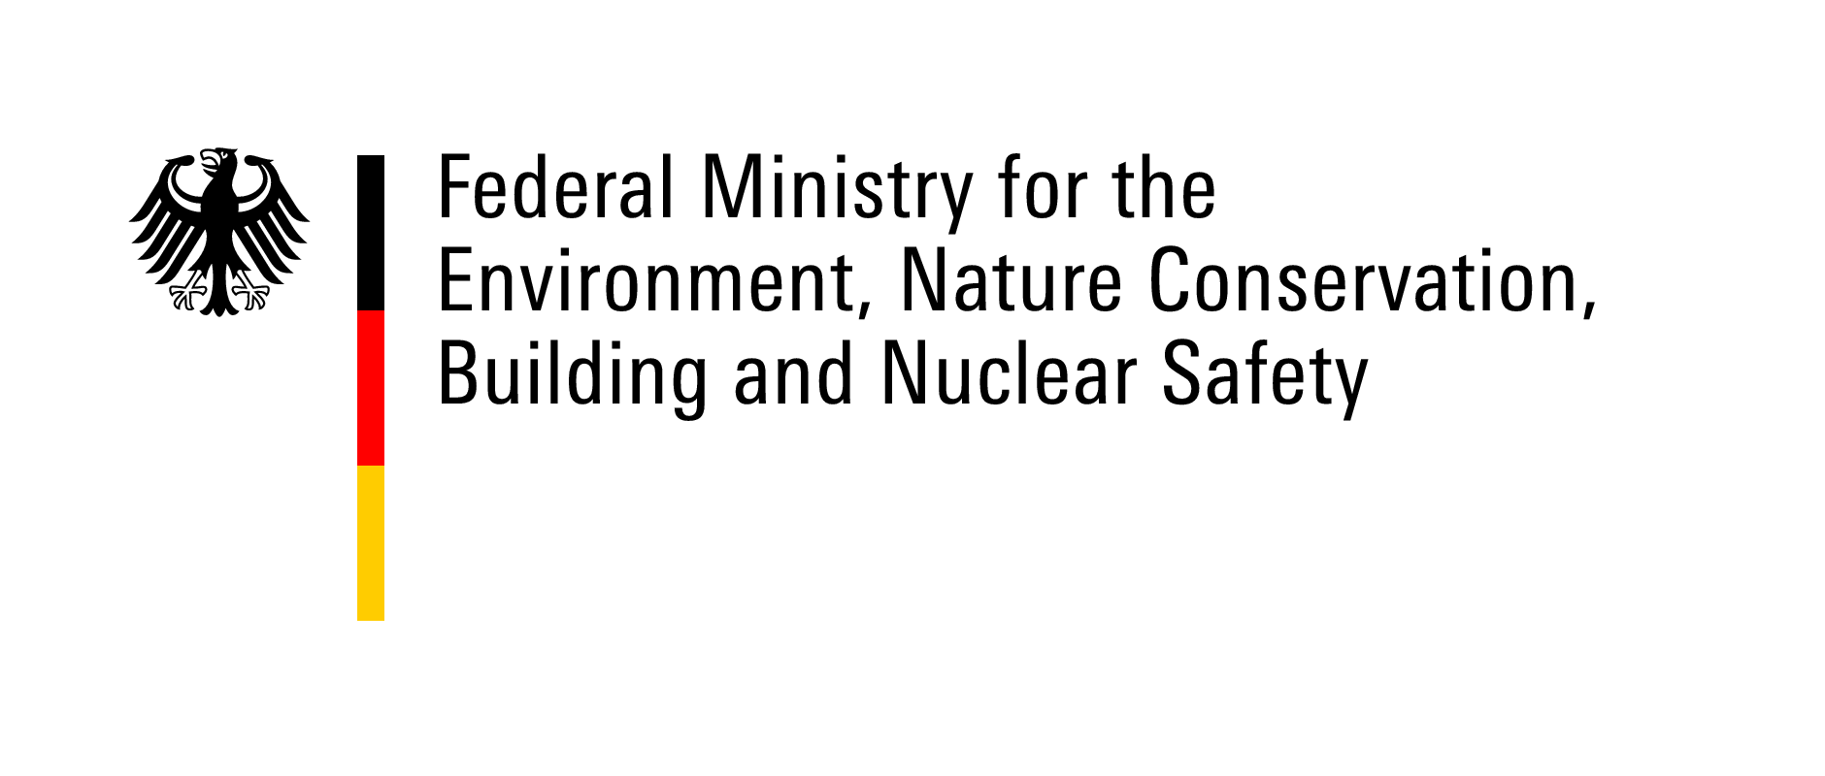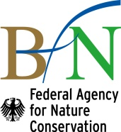
- Annex II – Memorandum of Cooperation

Memorandum of Cooperation

between the

Secretariat of the Framework Convention on the Protection and Sustainable Development of the Carpathians (Carpathian Convention)
and the

International Council for Game and Wildlife Conservation (CIC)

The Secretariat of the Carpathian Convention and the CIC (hereinafter referred to as "the Participants")

Considering that the Framework Convention on the Protection and Sustainable Development of the Carpathians (hereinafter referred to as the “Carpathian Convention") is a sub-regional treaty to foster the sustainable development and the protection of the Carpathian region, signed by seven Carpathian States (Czech Republic, Hungary, Poland, Romania, Serbia, Slovak Republic, and Ukraine) in 2003 and entered into force in 2006. The Carpathian Convention is the only multi-level governance mechanism which covers the entire Carpathian region. Its vision is to pursue comprehensive policies and cooperation to protect and sustainably develop the Carpathian mountain region.

Considering that the Carpathian Convention stands for the improvement of livelihoods in the Carpathians while conserving natural values and cultural heritage in part by providing assistance to its member states in the management and conservation of wildlife.

Considering that the Carpathian Convention has a high interest in issues related to the conservation, sustainable use, and restoration of biological diversity throughout the Carpathians with the Parties taking measures to ensure a high level of protection and sustainable use of wildlife and their habitats which are characteristic of the Carpathians and equally take measures to prevent the introduction of, or control and eradicate, invasive alien species.

Considering that the International Council for Game and Wildlife Conservation (hereinafter referred to as "CIC") is a global organization, established in 1935 under the French Law on associations of 1st July 1901, then with the seat in Paris/France, recognized in 2003 according to the Federal Law of the Republic of Austria on granting privileges to international nongovernmental organizations (BGB1. Nr. 174/1992) as International Non-Governmental Organization, working in the public interest, and subsequently since then with legal seat in Vienna/Austria and its Headquarters in Budapest, Hungary is aiming at a world that values and supports sustainable hunting for the benefit of people and nature (Vision of the CIC) through promoting, on a global scale, sustainable hunting as a tool for conservation while building on valued traditions (Mission of the CIC).

Considering that the CIC has members (states, hunting associations and federations, research organizations, as well as individuals) in 81 countries and is a recognized inter-governmental observer organization of the Convention on Biological Diversity (CBD) and the Convention on International Trade in Endangered Species of Wild Fauna and Flora (CITES). The CIC also has concluded a partnership agreement with the Convention on
Migratory Species (CMS) in 2005.

Recognizing that partnership between the Carpathian Convention and the CIC could be productive and systematic with the creation of a dynamic program embodying the visions and missions of both organizations, which would assist the Carpathian Convention and the CIC in their efforts towards the achievement the objectives of a number of International Multilateral Environmental Agreements.

Have reached the following understanding:

Section 1. Objective

The main objective of this cooperation is to enhance the capacity of countries in the Carpathian region in conserving and sustainably managing wildlife resources, thereby contributing to biodiversity conservation, food safety and nutrition (food security), wildlife, livestock, human health, and social and economic development.

Section 2. Scope of cooperation

With a view to attaining the above objective, the cooperation envisaged by this Memorandum of Cooperation may include collaboration within the framework of the work programs of the two Participants on the following types of activities:

- Identifying, documenting, and disseminating successful experience and best practices on management, conservation and sustainable use of wildlife;
- Promoting exchange of data and information on species;
- Mutually recommending experts upon request that could contribute to technical assistance programs in sustainable use, management and conservation of wildlife. It is understood that the respective Participant will keep the ultimate responsibility to select and appoint the experts;
- Promoting networks of professional experts in fields related to wildlife conservation, sustainable use of wildlife resources, veterinary health, food safety, combating and preventing wildlife crime, wildlife disease reporting, etc.;
- Developing joint projects within the scope of their collaboration, mainly (but not restricted to) demonstrating best practice, to test innovations, and to train human resources. Jointly identifying financial resources and execution modalities for the implementation of developed projects;
- Assisting the Carpathian Convention in organizing conferences, seminars, training workshops, outreach and other extension services, and technical meetings on matters related to sustainable use, the conservation of wildlife, wildlife monitoring, combating and preventing wildlife crime, disease surveillance and reporting, prevention of disease spread through hunting practices, invasive alien species, and veterinary public health at global, regional and country level;
- Demonstrating the collaboration through representatives of the Participants participating in the different fora at various levels of the other organizations;
- Communicating the results of their joint work through joint press releases, via internet postings, joint publications in public, and general and professional media.

Section 3. Annual work plan

Subsequent to this Memorandum of Cooperation, a work plan will be discussed annually for common areas of work and the concrete activities to be carried out in collaboration. The outcome of this discussion will be annexed to this Memorandum of Cooperation. Both the Secretariat of the Carpathian Convention and the CIC will designate a focal point for the coordination of the communication with each other.

Nothing in this Memorandum shall create or imply a financial obligation by either Participant to this Memorandum. Any financial questions will be regulated by separate letters of arrangements related to possible future projects or joint activities. It is recognized that for certain activities to be implemented fully, additional resources may be required. Participants will endeavor to carry out joint fundraising for this purpose.

Section 4. Use of official logos

The Participants will not use in any press release, memo, report, website, or other published disclosure related to this Memorandum of Cooperation any of the other Participants' name and logo without prior written consent by the Participant concerned.

Section 5. Disputes

- Any dispute about the interpretation or application of this Memorandum will be resolved by consultations between the Participants, and will not be referred to any national or international tribunal or third party for settlement.

Section 6. Amendment

- The Participants may amend this Memorandum by mutual written consent, which will be appended to this Memorandum and become an integral part of it.

Section 7. Termination

- This Memorandum of Cooperation may be terminated by the Participants at a jointly approved time or by one Participant giving three months' notice in writing to the other Participant.

- This Memorandum of Cooperation represents the understanding reached between the Participants upon its signature by the Carpathian Convention Secretariat and the CIC.

Section 8. Final provisions

      - Nothing in this Memorandum of Cooperation will bind any of the participants either jointly or severally.

Signed in duplicate at Rožnov pod Radhoštěm, Czech Republic on the 19 October 2016 in the English.

Signatures

On behalf of the  Secretariat of the Framework Convention on the Protection and Sustainable Development of the Carpathians (Carpathian Convention) | On behalf of the  International Council for Game and Wildlife Conservation (CIC)

- Annex III – pictures from the Conference

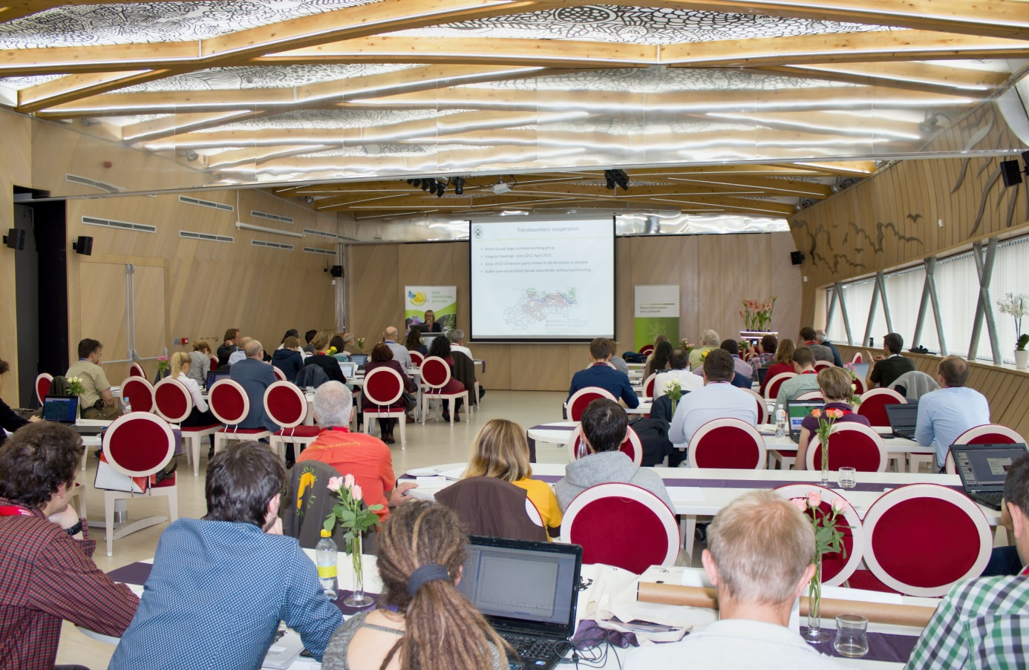
Picture 1 – The meeting room

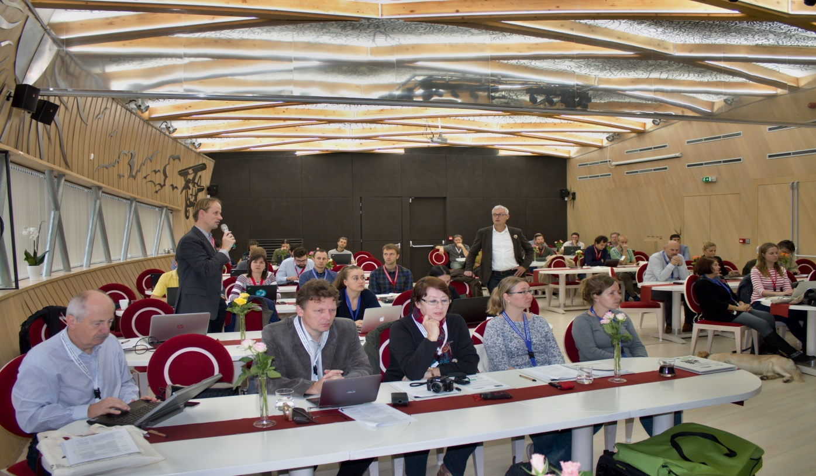
Picture 2 – Discussion after presentations
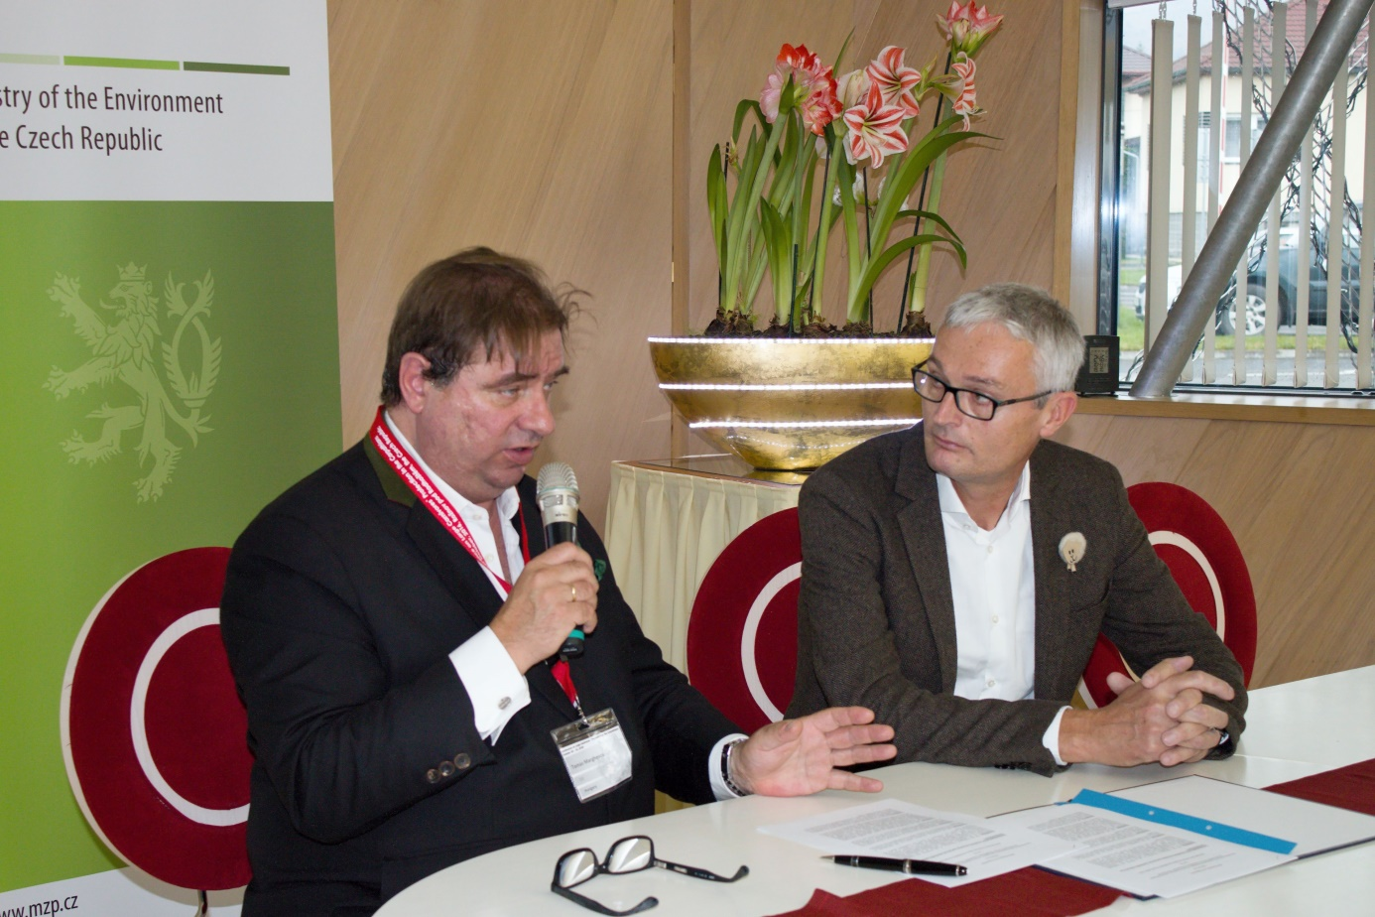
Picture 3 – Mr. Marghescu and Mr. Egerer – signature of the Memorandum between CIC and the Carpathian Convention

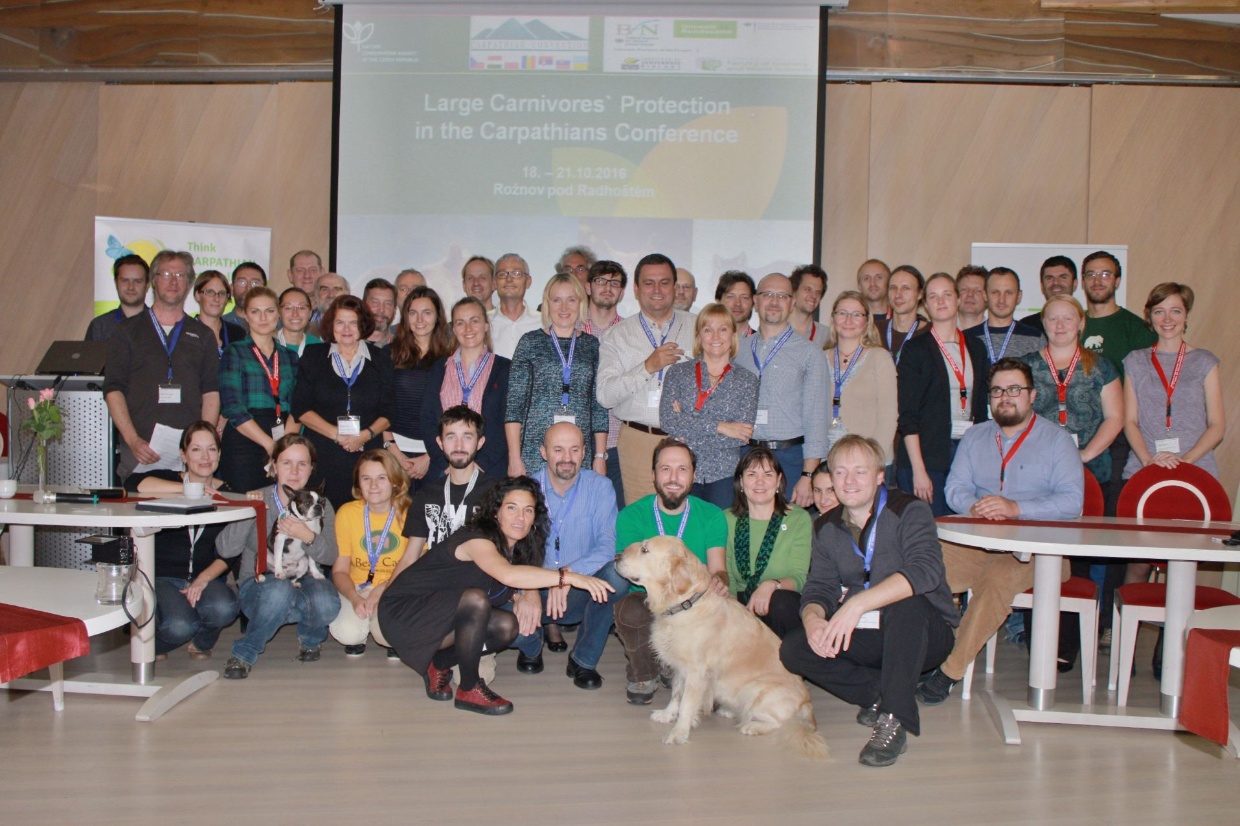
Picture 4 – Final group photo

Article 1 para 2 of the Carpathian Convention Protocol on Conservation and Sustainable Use of Biological and Landscape Diversity.
Key actions for Large Carnivore populations in Europe Prepared for DG Environment, European Commission, by Istituto Ecologia Applicata, Rome under contract no. 07.0307/2013/654446/SER/B3 "Support to the European Commission's policy on large carnivores under the Habitat Directive - Phase Two”, with contributions from the Large Carnivore Initiative for Europe (SSC/IUCN)
Recommendation No. 74 (1999) on the conservation of large carnivores, adopted by the Standing Committee on 3 December 1999; Recommendation No. 82 (2000) on urgent measures concerning the implementation of action plans for large carnivores in Europe, adopted by the Standing Committee on 1 December 2000; Recommendation No. 100 (2003) on conservation of large carnivores in the Carpathians, adopted by the Standing Committee on 4 December 2003 ; Recommendation No. 115 (2005) on the conservation and management of transboundary populations of large carnivores, adopted by the Standing Committee on 1 December 2005

