**LOGISTIC NOTE**

**14th Meeting of the Carpathian Convention Implementation Committee**

14-16 June 2023, Mszana Dolna, Poland

1. **Registration:**

Please register as soon as possible, at the latest by **16 May 2023** on this website: [REGISTRATION LINK](http://www.carpathianconvention.org/online-registration-ccic-2023.html)

1. 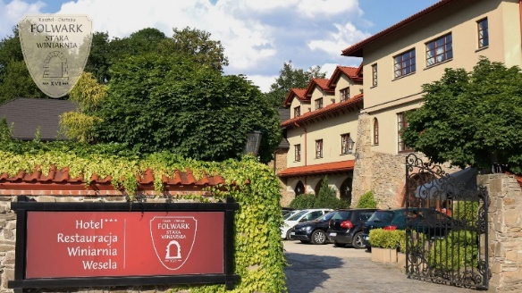**Venue:**

**Hotel Folwark Stara Winiarnia**

Adress:

Ogrodowa Str. 2

34-730 Mszana Dolna

Poland

<https://folwarkstarawiniarnia.pl/en/lang>

1. **Getting there:**

**By plane:**

The closest airport is Kraków John Paul II International Airport (KRK).

Organizers are planning to provide transport with one minibus from the Kraków airport to the venue of the meeting, leaving the airport on 14 June 2023, exact time depending on the arrival times of the participants.

There is also a convenient train connection between Kraków Airport and Kraków Główny train station – there are 2 trains every hour and the journey takes 20 minutes:

<https://krakowairport.pl/en/passenger/transport-en/directions/from-to-krakow-airport/train-en/>

From Kraków Główny there is a minibus to Mszana Dolna (see the details below).

**By train:**

The closest major train station is Kraków Główny (Kraków Main Train Station).

Organizers are planning to provide transport with one minibus from the Kraków Główny train station, leaving the station on 14 June at 14:15.

From Kraków Główny there is a minibus to Mszana Dolna (see the details below).

**By minibus from Kraków Główny to Mszana Dolna:**

The fastest way from Kraków Główny to Mszana Dolna is by minibus – several minibuses leave Kraków Główny Bus Station (next to the train station) every hour, the journey takes around 1 hour 10 minutes, one way ticket costs around 15 PLN:

<https://www.busy-krk.pl/en/mszana-dolna-krakow/>

Minibuses stop at the Bus Station in Mszana Dolna – within walking distance from the venue:

**Return to Kraków:**

The organizers will provide transport back to the Kraków Główny station on Friday, 16 June, leaving from the hotel at 12:00 (in order to catch the trains that leave at 14:00 and later) .

Those who do not wish to use organized transport can take a minibus to Kraków Główny by themselves.

1. **Accommodation:**

Block reservation with special rates is secured at the hotel Folwark Stara Winiarnia until **30 May 2023**.

Participants are kindly requested to book the hotel individually at [biuro@folwarkstarawiniarnia.pl](mailto:biuro@folwarkstarawiniarnia.pl), indicating that they will attend the Carpathian Conference meeting organised by the Ministry of Climate and Environment of Poland.

At the moment of booking a room guests will be asked to pay at least 30% of the cost of the room.

Participants can book either a single room (207 PLN / person) or a place in a double room (144 PLN / person) – as the capacity of the hotel might not be sufficient for all participants, guests are encouraged to consider choosing accommodation in double rooms.

There are also other accommodation possibilities available in Mszana Dolna.

1. **Field trip:**

Participants of the 14th CCIC meeting are invited to take part in the field trip organised by the administration of the Gorce National Park. Please remember to take with you outdoor shoes and clothing appropriate for the weather.

**About Gorce National Park:**

The Gorce NP was established in 1981. It includes the central and north-east parts of the Gorce Range. The total cover of the GNP is 7,030 hectares and roughly a half of this area is under a strict nature conservation regime. GNP protects not only the Gorce Range’s nature but also a rich cultural heritage.

The Carpathian forest is the most important treasure in the GNP. Lower elevations are covered with mixed forest called the Carpathian Beech Forest. It is only slightly affected by human activities in the past. The highest elevations are occupied by sub-alpine spruce forests. The forest dynamics is mostly of natural character – trees get old then die giving place for new generations of woody vegetation. The glades spread

out among comprehensive forest cover enrich the Gorce’s biodiversity and elevate its landscape values. The glades along with regional Zagórze or Podhale type woody huts are remnants of the traditional pastoral activities in this area. A wandering lengthwise Gorce tourist trails is very attractive since one may watch even other ranges, especially the Tatra Mountains.

More information: <https://www.gorczanskipark.pl/index.php?lang=2>

1. **Contacts:**

UN Environment Vienna Programme Office – SCC:

Klaudia Kuraś

Email: [klaudia.kuras@un.org](mailto:klaudia.kuras@unvienna.org), tel: (+ 43-1) 26060-5620, mobile: (+43) 699 173 800 17

Ministry of the Climate and Environment of Poland:

Bożena Haczek

Phone: +48 22 3692423

Email: [karpaty@mos.gov.pl](mailto:karpaty@mos.gov.pl)