
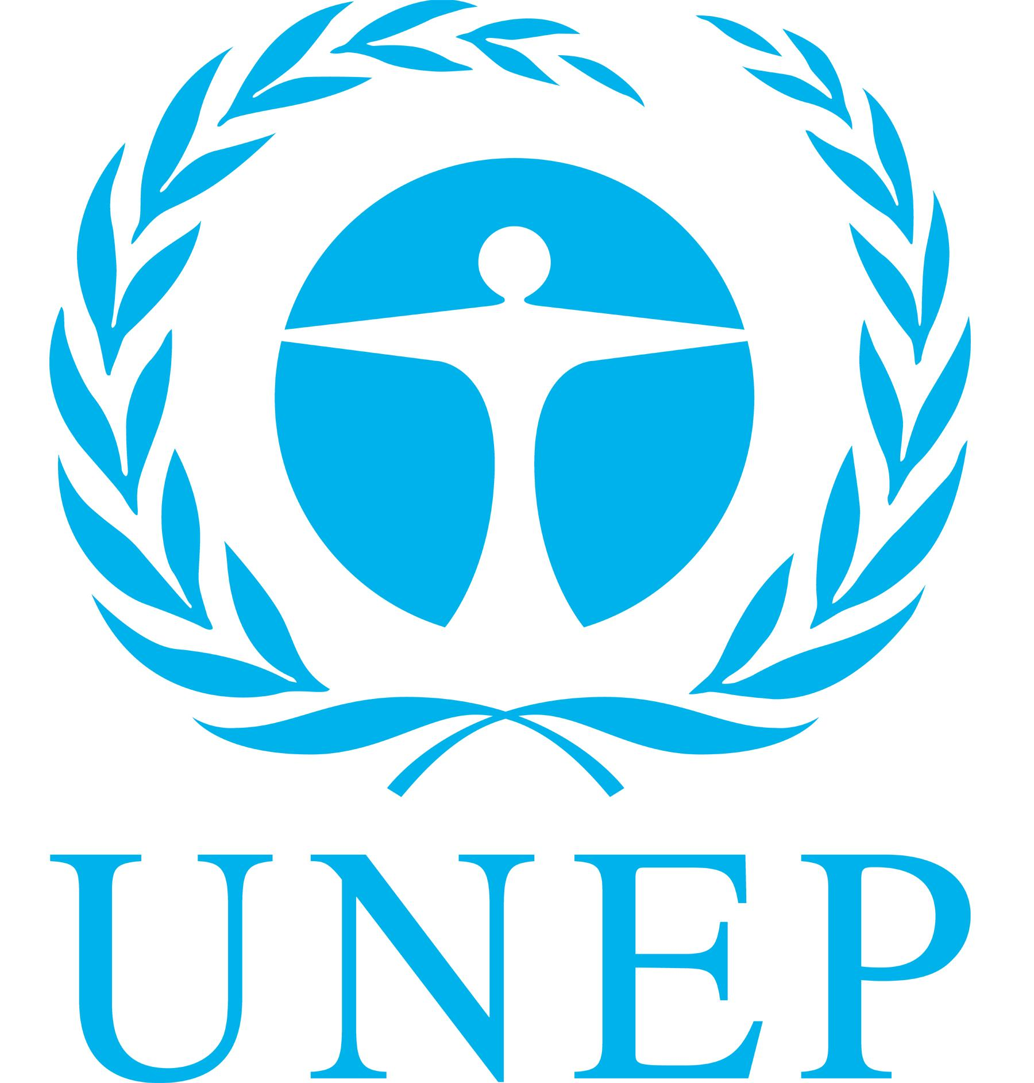
UNEP/CC/CCIC5/1
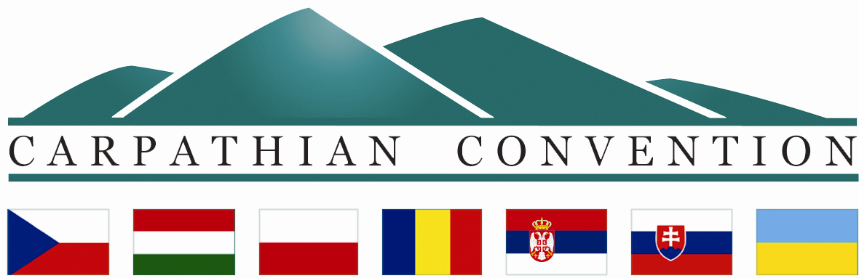

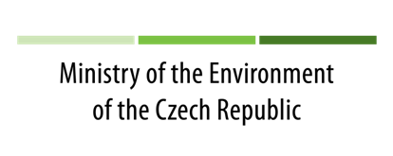
CARPATHIAN CONVENTION IMPLEMENTATION COMMITTEE (CCIC)

FIFTH MEETING
Prague, the Czech Republic
18 – 20 February 2014

DRAFT AGENDA

- Opening of the meeting by the Slovak Presidency
- Welcome speech by the host – the Ministry of the Environment of the Czech Republic
- Adoption of the Agenda
- Status of contributions, Status of signatures and ratifications of Biodiversity, Forest and Tourism Protocols
- Implementation of the Programme of Work of the Carpathian Convention - Progress report - and presentation of related projects and initiatives:
  - Conservation and sustainable use of biological and landscape diversity: Secretariat Report (Article 4 of the Carpathian Convention)
      - Presentation of the outcomes of the ETC SEE BIOREGIO Carpathians project
      - Presentation on cooperation with the European Landscape Convention
  - Spatial development: Secretariat Report (Article 5 of the Carpathian Convention)
  - Sustainable and integrated water/river basin management: Secretariat Report (Article 6 of the Carpathian Convention)
  - Sustainable agriculture, rural development and forestry: Secretariat Report (Article 7 of the Carpathian Convention)
  - Sustainable transport and infrastructure, industry and energy: Secretariat Report (Article 8 of the Carpathian Convention, Article 10 of the Carpathian Convention)
      - Presentation of the ETC SEE Access2Mountain project
  - Sustainable tourism: Secretariat Report (Article 9 of the Carpathian Convention)
  - Industry and energy: Secretariat Report (Article 10 of the Carpathian Convention)
  - Cultural heritage and traditional knowledge: Secretariat Report (Article 11 of the Carpathian Convention)
  - Environmental assessment/information system, monitoring and early warning (Article 12 of the Carpathian Convention)
  - Awareness raising, education and public participation: Secretariat Report (Article 13 of the Carpathian Convention)
  - Cooperation with the European Union: Secretariat Report
  - Cooperation with the Alpine Convention: Secretariat Report
  - Cooperation with other conventions and international bodies: Secretariat Report
  - Climate change: Secretariat Report
      - Presentation of the outcomes of CARPATCLIM, CARPIVIA and CarpathCC projects
- Administration and financial management of the Carpathian Convention and its Protocols: Update of the Secretariat
- Discussion on draft programme of work for 2015 – 2017
- Preperation for COP4 (draft agenda, draft programme, list of documents, organization of work, credentials, full power for Protocol signatures etc...)
- Review of list of Draft Decisions for COP4
- Location of the Permanent Secretariat: Update of the Secretariat
- Other matters
- Closure of the Meeting

The meeting is organised within the European Transnational Cooperation South East Europe BIOREGIO Carpathians project – WP 7 and with support of the Ministry of the Environment of the Czech Republic

