
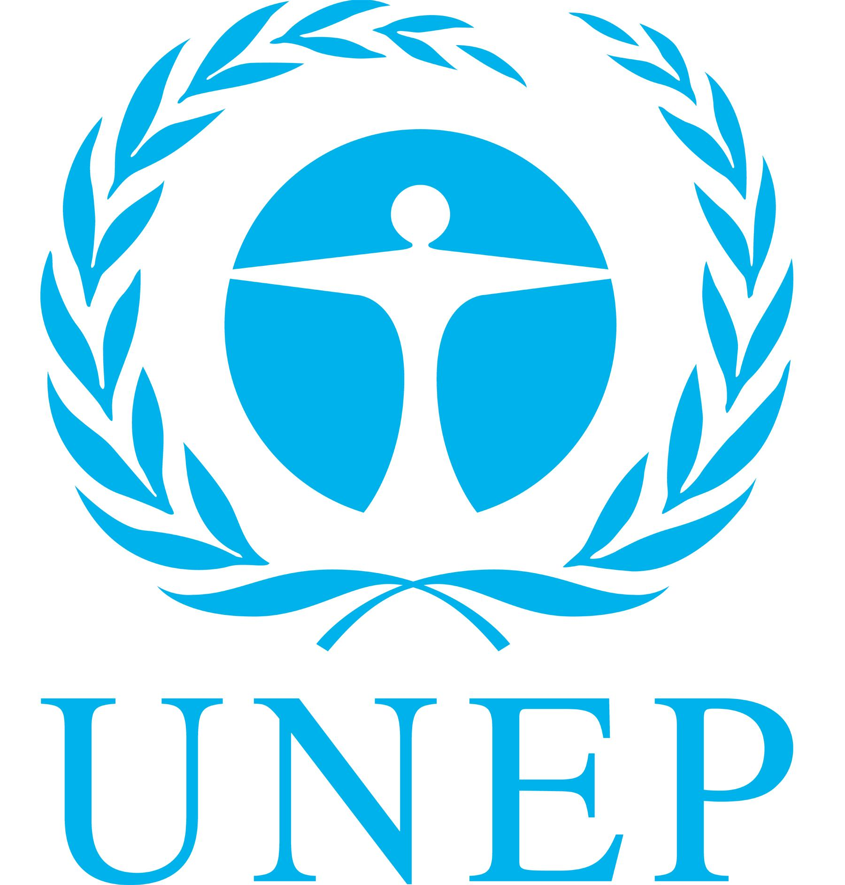
UNEP/CC/CCIC5/2
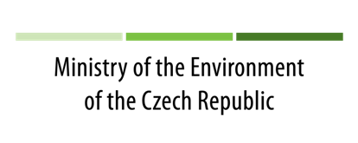
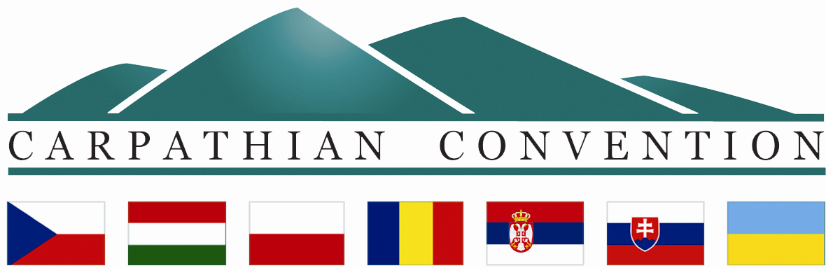

CARPATHIAN CONVENTION IMPLEMENTATION COMMITTEE (CCIC)

FIFTH MEETING
Prague, the Czech Republic
18 – 20 February 2014
DRAFT PROGRAMME

Tuesday, 18 February 2014

14:00 – 15:30 | Opening of the meeting by the Slovak Presidency  Welcome speech by the host – the Ministry of the Environment of the Czech Republic  Adoption of the Agenda  Status of contributions, Status of signatures and ratifications of Biodiversity, Forest and Tourism Protocols  Implementation of the Programme of Work of the Carpathian Convention - Progress report - and presentation of related projects and initiatives:  - Conservation and sustainable use of biological and landscape diversity: Secretariat Report (Article 4 of the Carpathian Convention)  - Presentation of the outcomes of the ETC SEE BIOREGIO Carpathians project (Mircea Verghelet, Piatra Craiului National Park, Romania)  - Presentation on cooperation with the European Landscape Convention (Pavlina Misikova, the Ministry of the Environment, Slovakia)  - Spatial development: Secretariat Report (Article 5 of the Carpathian Convention)
15:30 – 15:50 | Coffee break
15:50 – 18:30 | - Sustainable and integrated water/river basin management: Secretariat Report (Article 6 of the Carpathian Convention)  - Sustainable agriculture, rural development and forestry: Secretariat Report (Article 7 of the Carpathian Convention)  - Presentation of the Strategic Action Plan for the Protocol on Sustainable Forest Management  - Sustainable transport and infrastructure, industry and energy: Secretariat Report (Article 8 of the Carpathian Convention, Article 10 of the Carpathian Convention)  - Presentation of the final draft CC Protocol on Sustainable Transport  - Presentation of the ETC SEE Access2Mountain project
20.00 | Official Dinner - Upon invitation of ISCC and host country

Wednesday, 19 February 2014

9:00 – 11:30 | - Sustainable tourism: Secretariat Report (Article 9 of the Carpathian Convention)  - Presentation of the draft version of the Strategy for the Future Sustainable Tourism Development of the Carpathians (Michael Meyer, ETE)  - Cultural heritage and traditional knowledge: Secretariat Report (Article 11 of the Carpathian Convention)  - Presentation of the final draft version of the CC Protocol on Cultural Heritage and Traditional Knowledge  - Environmental assessment/information system, monitoring and early warning: Secretariat Report (Article 12 of the Carpathian Convention)  - Awareness raising, education and public participation: Secretariat Report (Article 13 of the Carpathian Convention)  - Cooperation with the European Union: Secretariat Report  - Cooperation with the Alpine Convention: Secretariat Report  - Cooperation with other conventions and international bodies: Secretariat Report  - Climate change: Secretariat Report  - Presentation of the outcomes of CARPATCLIM, CARPIVIA and CarpathCC projects (Sandor Szalai, Szent Istvan University, Hungary)
11:30 – 11:50 | Coffee break
11:50 – 13:00 | - Administration and financial management of the Carpathian Convention and its Protocols: Update of the Secretariat
13:00 – 14:30 | Lunch
14:30 – 16:40 | - Administration and financial management of the Carpathian Convention and its Protocols: Discussion  - Discussion on draft programme of work for 2015 – 2017
16:40 – 17:00 | Coffee break
17:00 – 19:00 | - Preperation for COP4 (draft agenda, draft programme, list of documents, organization of work, credentials, full power for Protocol signatures etc...)  - Review of list of Draft Decisions for COP4
20.00 | Free evening

Thursday, 20 February 2014

09.00 – 11.00 | - Location of the Permanent Secretariat: Update of the Secretariat  - Location of the Permanent Secretariat: Discussion
11.00 – 11.20 | Coffee break
11:20 – 13.00 | - Location of the Permanent Secretariat: Discussion continuation  Other matters  Closure of the meeting

The meeting is organised within the European Transnational Cooperation South East Europe BIOREGIO Carpathians project – WP 7 and with support of the Ministry of the Environment of the Czech Republic

