(topic, in bold)
Who we are
(Name of the organisation)

(Contact – name, telephone and email)

Country:
 | We want to submit a proposal. |  |  | We want to join a consortium.

What we do
- Your project idea/proposal, or
- The expertise you could bring to a consortium

Objectives:

Foreseen activities:

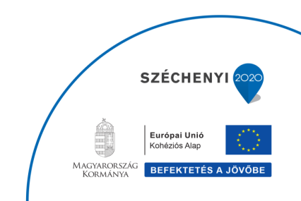
What we look for
- The expertise you need for your potential project/proposal, or
- Potential projects you are interested in
- EUSDR Cooperation in water education
- Water scarcity, regional drought management,
- Reconstruction of multiple water establishments
- Establishment of operative safety units, regional safety centres
- Hydromorphological alterations
- Urban waste water treatment
- Water quality innovations
- Resource efficient water management
- Fisheries management

