**NATIONAL REPORT**

ON THE IMPLEMENTATION

OF THE PROTOCOL ON SUSTAINABLE TOURISM TO THE FRAMEWORK CONVENTION ON THE PROTECTION AND SUSTAINABLE DEVELOPMENT OF THE CARPATHIANS

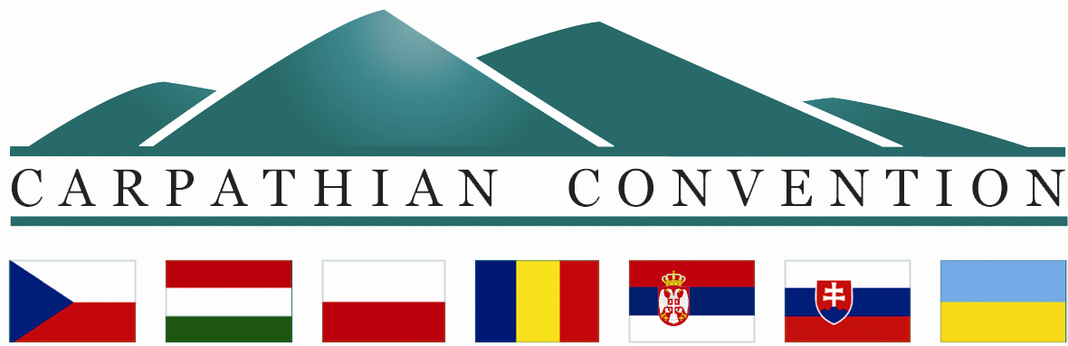

National Report to be submitted to the Interim Secretariat of the Carpathian Convention

[country – date]

**Introduction & background**

This National Report has been elaborated in accordance with the Framework Convention on the Protection and Sustainable Development of the Carpathians[1], its Protocol on Sustainable Tourism[2] adopted in Bratislava on the 27th April 2011 which entered into force on the 29th April 2013, and its Strategy for Sustainable Tourism Development of the Carpathians adopted at the Fourth Meeting of the Conference of the Parties to the Carpathian Convention (COP4)[3].

According to Article 32.1 of the Protocol, “*The Parties shall regularly report to the Conference of the Parties on measures related to this Protocol and the results of the measures taken*”.

According to Article 33.1 of the same Protocol, “*The Parties shall regularly examine and evaluate the effectiveness of the provisions of this Protocol*”.

**INSTITUTIONAL INFORMATION – REPORTING PARTY**

|  |  |
| --- | --- |
| Name of the reporting Party |  |
| ADMINISTRATIVE AUTHORITY | |
| Full name of the institution/administrative authority |  |
| Name and title of National Focal Point |  |
| Mailing address |  |
| Telephone |  |
| Fax |  |
| Email |  |

|  |  |
| --- | --- |
| **CONTACT PERSON(S) PARTICIPATING IN THE COMPILATION OF THE REPORT (IF DIFFERENT FROM ABOVE)** | |
| Full name of the institution/administrative authority |  |
| Name and title of person(s) |  |
| Mailing address |  |
| Telephone |  |
| Fax |  |
| Email |  |

|  |  |
| --- | --- |
| **SUBMISSION** | |
| Date of submission |  |

**A. GENERAL INFORMATION OF NATIONAL IMPLEMENTATION PROGRESS AND CHALLENGES**

**A.1** Which are the legal, policy and institutional achievements on national and regional levels since the adoption of the Protocol in your country, aiming at its implementation and the realisation of its objectives?

Please give a short summary of all relevant measures, laws, projects, programs, initiatives, multilateral agreements, etc.

Please identify and give a short description of the main touristic destinations of the Carpathian region found in your national territory.

Please identify and give a short description of the main sustainable tourism products of the Carpathian region found in your national territory.

**B. ACHIEVEMENTS AND FURTHER IMPLEMENTATION INFORMATION**

**B.1** Please indicate by marking an “X” in the appropriate column below, the level of realisation of the expected steps listed in the Strategy according to the objective. Please provide further information and details, if appropriate, on the activities developed in the indicated field.

|  |  |  |  |  |
| --- | --- | --- | --- | --- |
| **Objective 1 – Establishing of supportive conditions for the sustainable tourism products and services, including development of a marketing scheme for the promotion of the Carpathians as a unique sustainable tourism destination**  *Pursuant to Articles 4, 8, 9 and 10 of the Protocol* | | | | |
| **Expected steps** | **Comprehensive measures taken (fully achieved)** | **Some measures taken (partially achieved)** | **Not achieved** | **No information** |
| **1.a.** The Government took steps to adjust legal and voluntary frameworks for the support of sustainable tourism |  |  |  |  |
| *Possible comments and details* |  | | | |
|  | | | | |
| **1.b.** Measures were taken to establish common quality standards to be integrated in a common labelling system |  |  |  |  |
| *Possible comments and details* |  | | | |
|  | | | | |
| **1.c.** Measures were taken to develop a common brand for touristic products and destinations in the Carpathians |  |  |  |  |
| *Possible comments and details* |  | | | |
|  | | | | |
| **1.d.** Measures were taken to establish a network of ecotourism destinations in the Carpathians |  |  |  |  |
| *Possible comments and details* |  | | | |
|  | | | | |

|  |  |  |  |  |
| --- | --- | --- | --- | --- |
| **Objective 2 – Develop tourism management, fully integrating the needs of local people and economies and other supporting sectors, and respecting the preservation of natural and cultural heritage**  *Pursuant to Articles 11, 21, 22 and 23 of the Protocol* | | | | |
| **Expected steps** | **Comprehensive measures taken (fully achieved)** | **Some measures taken (partially achieved)** | **Not achieved** | **No information** |
| **2.a.** The Government developed a support scheme for the sustainable use of authentic landscapes and wilderness areas, with associated tourism infrastructure |  |  |  |  |
| *Possible comments and details* |  | | | |
|  | | | | |
| **2.b.** Small and micro business are supported and incentive polices were set in place. |  |  |  |  |
| *Possible comments and details* |  | | | |
|  | | | | |
| **2.c.** Possible direct or indirect, short-term or long-term influences, which are likely to have an adverse effect on the environment, biological and landscape diversity and cultural heritage, were assessed |  |  |  |  |
| *Possible comments and details* |  | | | |
|  | | | | |

|  |  |  |  |  |
| --- | --- | --- | --- | --- |
| **Objective 3 – Establish a continuous process of awareness raising, capacity building, education and training on sustainable tourism development and management at all levels**  *Pursuant to Articles 18, 19, 20 and 28 of the Protocol* | | | | |
| **Expected steps** | **Comprehensive measures taken (fully achieved)** | **Some measures taken (partially achieved)** | **Not achieved** | **No information** |
| **3.a.** Contributions were made to the establishment of an information system providing data for both monitoring purposes and visitors |  |  |  |  |
| *Possible comments and details* |  | | | |
|  | | | | |
| **3.b.** Steps were taken to establish an online platform for product development, promotion marketing and monitoring |  |  |  |  |
| *Possible comments and details* |  | | | |
|  | | | | |
| **3.c.** Initiatives and projects aiming at raising awareness on sustainability issues related to sustainable tourism development in the Carpathians were promoted and supported |  |  |  |  |
| *Possible comments and details* |  | | | |
|  | | | | |

**B.2** Have you taken complementary measures to those planned by the present Protocol? If yes, please, list them.

**B.3** What have been the most successful aspects of the implementation of the Protocol?

**B.4** What have been the greatest difficulties in this implementation? Please tick your answers in the following list.

|  |  |
| --- | --- |
| Lack of political will and support |  |
| Limited public participation and stakeholder involvement |  |
| Lack of integration of the objectives of the Protocol into other sectors |  |
| Inadequate capacity to act, caused by institutional weakness |  |
| Lack of public education and awareness at all levels |  |
| Lack of understanding for the topic of sustainable tourism |  |
| Lack of financial, human, technical resources |  |
| Lack of economic incentive measures |  |
| Lack of synergies at national and international levels |  |
| Lack of cooperation between involved stakeholders at local and national levels |  |
| Lack of effective partnerships |  |
| Lack of appropriate policies and laws |  |
| Lack of precise definitions of potential misunderstanding notions |  |
| Others (please specify) |  |
| *Possible comments and details* |  |

**B.5** Which institutions in your country are the driving forces to implement the objectives of the Protocol? Are they in contact with similar institutions in your neighbouring countries?

**B.6** Are the local authorities or other stakeholders (NGOs, private sector…) encouraged to contribute to the implementation of the Protocol in their objectives and activities? Have they undertaken activities or actions aiming at implement better and further the Protocol?

**B.7** Do you have any other general comments or recommendations on the implementation of the Protocol?

1. Hereinafter named “the Convention”
2. Hereinafter named “the Protocol”
3. Hereinafter named “the Strategy”